FIRSTRAND BANK BA 900 Analysis

# South African Banks Loan-to-Deposit

BA900 JUNE 2022

|  |  |  |  |
| --- | --- | --- | --- |
| BANKS | DEPOSITS | LOANS | LOANS/DEPOSIT RATIO |
| FNB | 1.11081e+09 | 960670000 | 86.9% |
| CAPITEC | 139849531 | 96311762 | 68.8% |
| ABSA | 1.0844e+09 | 1.0877e+09 | 100% |
| NEDBANK | 894307034 | 838464912 | 93.7% |
| INVESTEC | 389730000 | 368920000 | 94.6% |
| STANDARD BANK | 1.1615e+09 | 1.1896e+09 | 102.4% |

BA900 JULY 2022

|  |  |  |  |
| --- | --- | --- | --- |
| BANKS | DEPOSITS | LOANS | LOANS/DEPOSIT RATIO |
| FNB | 1.11081e+09 | 965380000 | 86.9% |
| CAPITEC | 142275225 | 99590199 | 70% |
| ABSA | 1.1003e+09 | 1.0896e+09 | 99% |
| NEDBANK | 913385099 | 822876527 | 90% |
| INVESTEC | 411560625 | 372650000 | 90.5% |
| STANDARD BANK | 1.1710e+09 | 1.1658e+09 | 99.5% |

BA900 AUG 2022

|  |  |  |  |
| --- | --- | --- | --- |
| BANKS | DEPOSITS | LOANS | LOANS/DEPOSIT RATIO |
| FNB | 1.1052e+09 | 948210000 | 85.8% |
| CAPITEC | 913385099 | 96326000 | 10.6% |
| ABSA | 1.1203e+09 | 1.1342e+09 | 101.2% |
| NEDBANK | 899500000 | 825087817 | 91.7% |
| INVESTEC | 397677060 | 382130000 | 96% |
| STANDARD BANK | 1.1934e+09 | 1.1583e+09 | 97.0% |

# South African Banks Market Share

JUNE JULY AUG 2022 Market share

|  |  |
| --- | --- |
| BANKS | Market Share |
| FNB | 21.8% |
| CAPITEC | 7.86% |
| ABSA | 21.6% |
| NEDBANK | 17% |
| INVESTEC | 7.86% |
| STANDARD BANK | 23% |

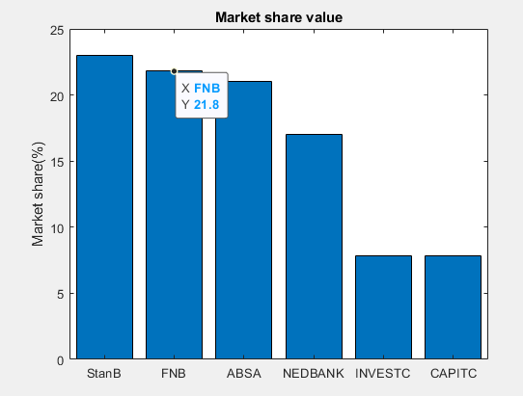

# South African Banks Monthly Net worth

BA900 JUNE 2022

|  |  |  |  |
| --- | --- | --- | --- |
| BANKS | Liabilities | Assets | Net Worth |
| FNB | 1.3765e+09 | 1.4798e+09 | 103241237 |
| CAPITEC | 148052616 | 179136862 | 31084246 |
| ABSA | 1.3674e+09 | 1.4672e+09 | 99836629 |
| NEDBANK | 1.0818e+09 | 1.1605e+09 | 78637457 |
| INVESTEC | 466574968 | 505404755 | 38829787 |
| STANDARD BANK | 1.5997e+09 | 1.7053e+09 | 105603459 |

BA900 JUNE 2022

|  |  |  |  |
| --- | --- | --- | --- |
| BANKS | Liabilities | Assets | Net Worth |
| FNB | 1.3891e+09 | 1.4953e+09 | 1.0614e+08 |
| CAPITEC | 151670819 | 183318247 | 31647428 |
| ABSA | 1.3551e+09 | 1.4565e+09 | 101398371 |
| NEDBANK | 1.0700e+09 | 1.1492e+09 | 79221342 |
| INVESTEC | 476857341 | 515626393 | 38769052 |
| STANDARD BANK | 1.5860e+09 | 1.6932e+09 | 107236693 |

BA900 AUG 2022

|  |  |  |  |
| --- | --- | --- | --- |
| BANKS | Liabilities | Assets | Net Worth |
| FNB | 1.3889e+09 | 1.4962e+09 | 1.0734e+08 |
| CAPITEC | 148618863 | 180910855 | 32291992 |
| ABSA | 1.4105e+09 | 1.5077e+09 | 97221732 |
| NEDBANK | 1.0550e+09 | 1.1317e+09 | 76777865 |
| INVESTEC | 533610493 | 493810664 | 39799829 |
| STANDARD BANK | 1.1934e+09 | 1.6968e+09 | 104963644 |

Average Monthly Net worth

|  |  |
| --- | --- |
| BANKS | Avg Net Worth |
| FNB | 1.0557e+08 |
| CAPITEC | 3.1675e+07 |
| ABSA | 9.9486e+07 |
| NEDBANK | 7.8212e+07 |
| INVESTEC | 3.9133e+07 |
| STANDARD BANK | 1.0593e+08 |